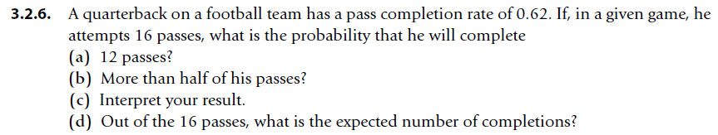



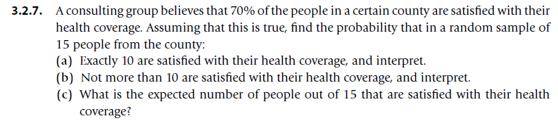



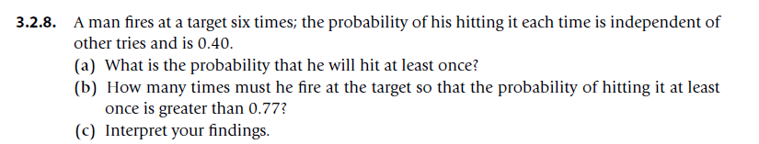



**Part (c): Interpretation of the Findings**

* **Part (a)** indicates a very high likelihood (approximately 95.3%) that the man will hit the target at least once in 6 attempts. This shows that even with a relatively moderate success rate of 40%, multiple attempts drastically increase the probability of at least one success.
* **Part (b)** shows that firing just 3 times gives a more than 77% chance of hitting the target at least once. This suggests that even with a lower number of attempts, the chances of success can still be relatively high due to the cumulative effect of multiple trials.

Overall, this demonstrates how multiple independent attempts at a moderately difficult task can significantly increase the likelihood of success.

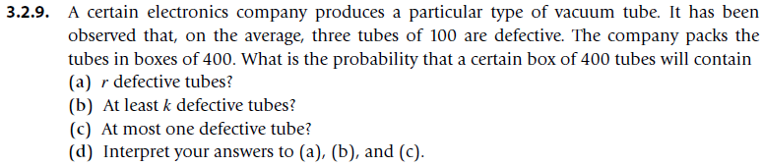



### Part (d): Interpretation of the Results

* **Part (a)**: The probability that a box will contain exactly rrr defective tubes helps in assessing how common a specific number of defects is. This is crucial for quality control to ensure that the defect rate is within acceptable limits.
* **Part (b)**: The probability of at least kkk defective tubes is important to understand the risk of having a significantly defective batch. It helps the company to gauge the chances of receiving a problematic shipment and decide on possible action plans.
* **Part (c)**: The probability of at most one defective tube indicates the likelihood of having a box with virtually no defects, which reflects the high quality of the manufacturing process. A high probability in this case would suggest excellent quality control.

